|  |  |
| --- | --- |
| **Orienteering**  **Beginner Compass Game** | C:\Users\james\OneDrive\BSA\Woodbadge\Project\EEE Flag Color.JPG |



**Setup Chart**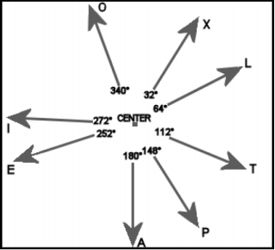

**Equipment:**

* Nine wooden stakes (included)
* One orienteering compass per patrol (1 included)
* One 50’ string
* Thirty game papers

**Object:** Teach basic compass skills.

**Example:** Given this game paper



A patrol would follow the path below starting at A and ending at T making the code “ALPETO”

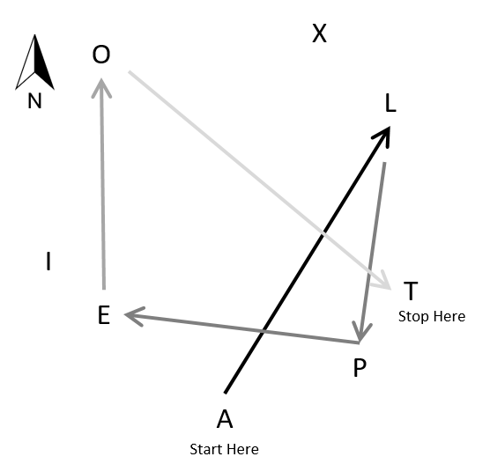

**Game Play:**

1. Give each patrol an orienteering compass and a “game paper”.
2. Each patrol starts at the stake labeled with the same letter on the letter their “game paper”.
3. Each patrol should set a bearing using the first number on the “game paper”
4. They should follow the bearing, reach a stake and note its labeled letter.
5. They should set a bearing for the next number and repeat until they have reached five stakes.
6. Upon finishing compare their sequence of letters against the answer sheet.

**Game Setup:**

1. In an open field stake the ‘center’ stake near the center of the field
2. Now stake ‘a’, ’e’, ’i’, ’o’ ,’x’, ‘l’, ‘t’, ‘p’ stakes 50’ from the center stake (use the 50’ string to keep the distance consistent) at the angle shown in the “setup chart”.

**Answer Sheet**

|  |  |  |
| --- | --- | --- |
| **#1 ALPETO  32 196 290 92 316** | **#11 IEOPXT 172 26 154 0 162** | **#21 XIOTLA**  **242 36 136 358 212** |
| **#2 EXLIPA 52 138 258 120 254** | **#12 OTLXPI**  **136 358 318 180 300** | **#22 LOATPI**  **292 170 56 220 300** |
| **#3 ITEPOL**  **102 272 110 334 112** | **#13 XPEOIL**  **180 290 26 216 78** | **#23 TXALPO**  **342 196 32 196 334** |
| **#4 OTALIX**  **136 236 32 258 62** | **#14 LPTIXO**  **196 40 282 62 276** | **#24 PXLOEA**  **0 138 292 206 126** |
| **#5 XILEPT**  **242 78 248 110 40** | **#15 TOELPI**  **316 206 68 196 300** | **#25 AOEXLP**  **350 206 52 138 196** |
| **#6 LOPIAE**  **292 154 300 136 306** | **#16 POITEL**  **334 216 102 272 68** | **#26 ETLIAX**  **92 358 258 136 16** |
| **#7 TPILXO**  **220 300 78 318 276** | **#17 AIPXEO**  **316 120 0 232 26** | **#27 IAXPOL**  **136 16 180 334 112** |
| **#8 PLIXEA**  **16 258 62 232 126** | **#18 EIXAOL**  **352 62 196 350 112** | **#28 OEXPTL**  **206 52 180 40 358** |
| **#9 APLXTO**  **74 16 318 162 316** | **#19 IOAPXE**  **36 170 74 0 232** | **#29 XLEAPO**  **138 248 126 74 334** |
| **#10 ELOIXP**  **68 292 216 62 180** | **#20 OAXIEP**  **170 16 242 172 110** | **#30 LXIAPT**  **318 242 136 74 40** |

**Game Papers**

|  |  |  |
| --- | --- | --- |
| **#1 A 32 196 290 92 316** | **#11 I 172 26 154 0 162** | **#21 X**  **242 36 136 358 212** |
| **#2 E 52 138 258 120 254** | **#12 O**  **136 358 318 180 300** | **#22 L**  **292 170 56 220 300** |
| **#3 I**  **102 272 110 334 112** | **#13 X**  **180 290 26 216 78** | **#23 T**  **342 196 32 196 334** |
| **#4 O**  **136 236 32 258 62** | **#14 L**  **196 40 282 62 276** | **#24 P**  **0 138 292 206 126** |
| **#5 X**  **242 78 248 110 40** | **#15 T**  **316 206 68 196 300** | **#25 A**  **350 206 52 138 196** |
| **#6 L**  **292 154 300 136 306** | **#16 P**  **334 216 102 272 68** | **#26 E**  **92 358 258 136 16** |
| **#7 T**  **220 300 78 318 276** | **#17 A**  **316 120 0 232 26** | **#27 I**  **136 16 180 334 112** |
| **#8 P**  **16 258 62 232 126** | **#18 E**  **352 62 196 350 112** | **#28 O**  **206 52 180 40 358** |
| **#9 A**  **74 16 318 162 316** | **#19 I**  **36 170 74 0 232** | **#29 X**  **138 248 126 74 334** |
| **#10 E**  **68 292 216 62 180** | **#20 O**  **170 16 242 172 110** | **#30 L**  **318 242 136 74 40** |